**SOFTWARE REQUIREMENTS SPECIFICATION DOCUMENTATION FOR ONLINE SHOPPING MART**

**INTRODUCTION**

**ABSTRACT**

In today's world, the preference for online shopping is widespread among consumers due to its convenience, accessibility, and time-saving benefits. Online Shopping Mart aims to provide to this trend by offering a user-friendly mobile application that facilitates purchasing for customers. The platform addresses various user needs, including product recommendations based on preferences, cart management, easy location input, payment options, order tracking, communication with delivery partners, as well as hassle-free return and refund processes. Furthermore, an administrator login allows for essential tasks such as adding new products, removing sold-out items, managing customer orders by approving or rejecting them, and monitoring order status.

**SYSTEM REQUIREMENTS**

**FUNCTIONAL REQUIREMENT**

The Functional Requirement Specification describes what tasks and activities a system can do. It is created to be understandable by the Customers.

* User Registration and Login Feature
* Browse and search Products
* Add products to Shopping Cart
* Checkout and Check the Shipping Address
* Payment and Discount Coupons
* Track Order Status
* Product Review by Customer

**NON-FUNCTIONAL REQUIREMENT**

The Non-functional Requirement Specification explains how well the system should perform and any limitations it must meet. what it can do. It's written so that anyone can understand it easily.

* Performance
* Scalability
* Security
* Availability
* Cross-platform Support

**MODULAR DESCRIPTION**

1. To sign in, users need to provide their email and a password. The password must be strong with at least two numbers, one letter, and one special character to ensure site security and speed.
2. The product catalog module organizes and displays various items for sale. It helps users find what they need by filtering products. It manages product listings, categories, and search functions efficiently.
3. Once logged in, users can see product details like price, reviews from other customers, product images, and special features.
4. After selecting a product, users can add it to their cart and choose the quantity. Then, they can enter their location or address and select a payment method. After successful payment, users can track their order.
5. Admins can log in and access the entire database and user accounts with maximum privileges. Only registered users can buy products; others cannot.

**SYSTEM ARCHITECTURE**

**FLOW CHART**

User visits website

NoN

Login with registered credentials

User registers an account

Is user new?

Yes

Order Placed

Payment Successful?

User browses products

**User adds product to the shopping cart**

User chooses payment method

User proceeds to checkout

User selects delivery address

NoN

Back to Shopping Cart

Yes

**USE CASE DIAGRAM**

This use case diagram illustrates the connections between customers and administrators.

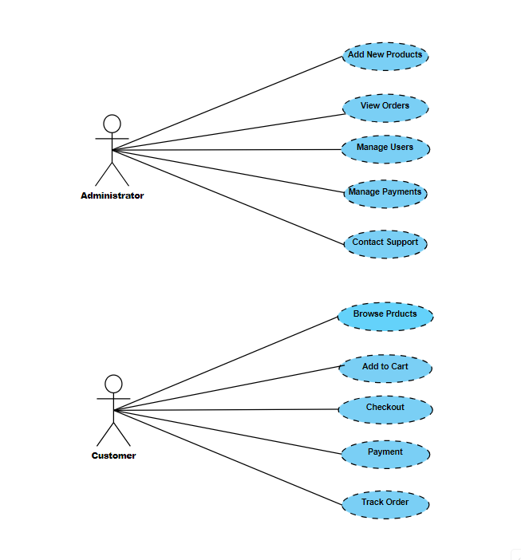

**CLASS DIAGRAM**

In this class diagram, the relationships between buyers and administrators are depicted.

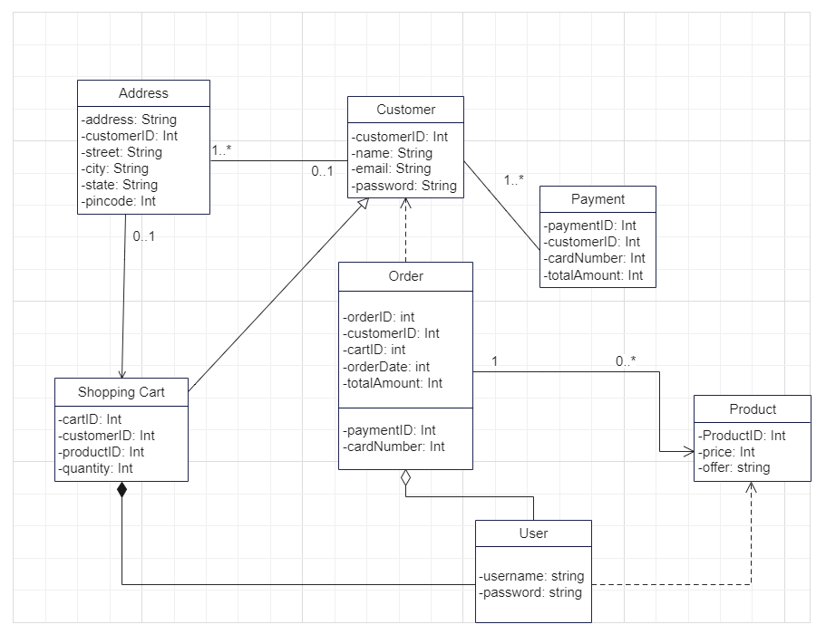

**SEQUENCE DIAGRAM**

In this sequence diagram, the interactions between buyers and administrators are illustrated.

